LEAD-VEHICLE DISTANCE ESTIMATION USING FORWARD VISION IN EGO-VEHICLES

By :
Anubuthi Kottapalli
Ashwin Ram Venkataraman
Hritik Jhaveri
Deepali Dagar

Supervisor: Dr. Igor Yakushin

A Capstone Project
Submitted to the University of Chicago in partial fulfillment
of the requirements for the degree of

Master of Science in Applied Data Science

Division of Physical Sciences
May 2025

Abstract
This project focuses on developing a vision-based system for lead-vehicle detection and distance estimation using monocular camera input. To address limitations of traditional RADAR and LiDAR sensors, the system incorporates depth models combined with camera intrinsics for accurate distance inference. Image segmentation is used to identify vehicles, faces, and license plates. To ensure privacy, personally identifiable information (PII) such as faces and license plates is filtered/blured from all processed images.

Keywords: Computer Vision, Visual Transformers, Deep Learning, Autonomous Vehicles, Monocular Distance Estimation, Image Processing, Real-time inference, PII Filtering, Image Segmentation

Executive Summary

This project addresses the challenge of estimating the distance to a lead vehicle using monocular camera input—an essential task for autonomous and semi-autonomous driving. Traditional sensors like RADAR and LiDAR are costly and sometimes unreliable in complex environments. The goal is to develop a low-cost, vision-based alternative that operates in real time and upholds privacy standards.
The proposed pipeline integrates object detection, monocular depth estimation, and structured modeling to infer lead-vehicle distance. Privacy filtering is handled through YOLO-based models that detect and blur faces and license plates. Depth estimation models include MiDaS, ZoeDepth, and Depth Anything. A geometric method using focal length and known license plate size is also considered for one-shot distance estimation via the pinhole camera model.
Training and testing are conducted using CARLA simulator data, with KITTI used to evaluate generalization. A gradient-boosted model (e.g., XGBoost) will be trained on structured features such as bounding box geometry and depth values. The final system is expected to meet targets such as ≤ 5% RMSE, ≥ 80% detection accuracy, and ≤ 60 ms inference time, while delivering annotated frames with distance overlays and blurred PII.
This work demonstrates the feasibility of accurate, privacy-compliant distance estimation using vision alone. Future directions include incorporating spatio-temporal modeling for improved consistency and exploring unified multi-task networks to streamline the entire pipeline.

Table of Contents

Introduction 1
Problem Statement 1
Analysis Goals 1
Scope 2
Background 3
Literature Review 4
Data 6
Data Sources 6
Descriptive Analysis 7
Methodology 9
Planned Approach Description 9
Methodology for Model Evaluation and Validation 12
Expected Results 12
References 14
List of Figures
Figure 1. Object Detection and Depth Overlay ……......................................................................8
Figure 2. Architecture Diagram ...................................................................................................11
List of Tables
Table 1. Key performance metrics.................................................................................................13

Introduction

Problem Statement
Although LiDAR and RADAR are widely used in autonomous driving for their accuracy in object detection and depth estimation, they present significant limitations. These include high installation and maintenance costs, hardware bulkiness, and reduced reliability in radar-constrained environments such as tunnels, dense urban canyons, or during adverse weather conditions (Choi et al., 2020). In contrast, vision-based systems using monocular cameras offer a lightweight, cost-effective, and scalable alternative, with the added advantage of being more suitable for deployment on edge devices. However, extracting reliable depth information from monocular imagery remains an open challenge due to the inherent lack of direct spatial cues. This study addresses the need for a robust, camera-only solution for estimating the distance to lead vehicles in real time, targeting edge-device deployability without compromising accuracy.

Analysis Goals
The primary objective is to design and implement an end-to-end pipeline that estimates the distance between the ego-vehicle and surrounding vehicles using only monocular vision. The system consists of three integrated components. First, object detection is performed using state-of-the-art models such as YOLO to localize vehicles within the camera feed. Second, monocular depth estimation is carried out using neural networks like MiDaS to generate pixel-wise depth information from single frames. Finally, a fusion stage employs hybrid ensemble models that combine geometric reasoning with learning-based predictions to generate final distance estimates for each detected object, along with associated confidence scores. The resulting system is scalable and capable of real-time inference, making it suitable for deployment in intelligent transportation applications.

Scope
This research focuses exclusively on forward-facing monocular camera inputs in urban driving environments. Data sources include simulated video streams from the CARLA autonomous driving simulator, which allow for controlled experimentation and validation against ground truth depth, as well as real-world dashcam footage provided by Argonne National Laboratory to assess performance under practical driving conditions. The solution is benchmarked on standard edge computing hardware to ensure real-time feasibility. Other sensory modalities such as LiDAR, stereo cameras, and RADAR are deliberately excluded in order to evaluate the standalone capabilities of monocular vision systems.

Background
Argonne National Laboratory is a U.S. Department of Energy research facility with active programs in clean energy systems, advanced computing, and intelligent mobility. Within Argonne, the Connected and Automated Vehicles (CAV) group focuses on data-driven research aimed at improving the safety, efficiency, and environmental sustainability of modern transportation systems. For the purpose of this project, the CAV team granted access to real-world urban driving data, collected from instrumented vehicles operating in diverse traffic and weather conditions. These video streams serve as a critical resource for evaluating computer vision models in realistic, uncontrolled environments.
In parallel, the project uses synthetic data generated through the CARLA simulation platform. CARLA provides a controlled environment in which ground truth depth values, object annotations, and camera parameters are readily accessible. This enables rigorous experimentation and facilitates the training and validation of monocular vision models across a range of driving scenarios. The use of simulation complements the real-world data by offering consistency and scalability during the early stages of model development.
Together, these two data sources enable a comprehensive investigation into monocular vision-based distance estimation, particularly for applications where LiDAR and RADAR sensors are unavailable or unreliable. This approach addresses a known gap in the literature, where models often perform well in simulation but fail to generalize to real-world data. By incorporating both real and synthetic inputs, the project aims to produce deployable solutions that are robust across varied conditions and suitable for edge-computing applications in intelligent transportation systems.

Literature Review
Computer vision techniques have seen broad adoption in transportation research, particularly in the development of advanced driver-assistance systems (ADAS) and autonomous vehicle (AV) technologies. A growing body of literature focuses on monocular camera-based distance estimation as an alternative to expensive and hardware-intensive sensors like LiDAR and RADAR. These studies aim to increase accessibility and scalability of intelligent vehicle systems by leveraging affordable vision-based solutions (García et al., 2017).
Early approaches to vehicle distance estimation relied on classical image processing methods, including edge detection, motion parallax, and shape-from-texture techniques (Geiger et al., 2012). These methods, however, were highly sensitive to noise, lighting changes, and object occlusions. With the rise of deep learning, convolutional neural networks (CNNs) and transfer learning architectures have become dominant in object detection and depth estimation tasks. Notably, YOLO (You Only Look Once) models have been extensively used for real-time object detection due to their ability to process images in a single forward pass with high accuracy and low latency (Redmon & Farhadi, 2018; Bochkovskiy et al., 2020). Variants such as YOLOv4 and YOLOv8 offer improved detection performance through architectural optimizations and integrated augmentation strategies, enabling applications in traffic monitoring, license plate recognition, and PII redaction (Wang et al., 2022).
Depth estimation from a single RGB image—traditionally considered an ill-posed problem—has been advanced by models such as MiDaS, ZoeDepth, and Depth Anything. MiDaS introduced a robust approach by training across multiple datasets with varying distributions, leveraging a Vision Transformer backbone to extract hierarchical representations (Ranftl et al., 2022). ZoeDepth builds on this by incorporating both relative and metric supervision to enable zero-shot transfer across datasets (Bhat et al., 2023). Depth Anything represents a further progression, trained on large-scale unlabeled data with supervision from Segment Anything-derived features to generalize across scenes and domains (Liu et al., 2024). These models have been used in applications ranging from indoor robotics to AR/VR depth mapping, demonstrating their versatility outside the transportation domain.
In addition to image-based distance estimation, geometric methods using known physical object dimensions (e.g., license plates or lane widths) and camera intrinsics have been explored for monocular range estimation. These techniques are often combined with learning-based models in hybrid systems to improve reliability, especially in edge-deployable solutions where real-time constraints are critical (Fabbri et al., 2018).

Data

Data Sources
This study utilizes forward-facing monocular video data from two primary sources:
- CARLA Simulator: Synthetic driving data generated at 30 frames per second, featuring diverse urban environments, weather conditions, and traffic scenarios. CARLA provides access to precise ground truth for both object locations and depth, enabling detailed evaluation of model performance.
- Argonne National Laboratory: Real-world driving footage collected by Argonne’s Connected and Automated Vehicles (CAV) team. The dataset captures urban driving conditions using dash-mounted monocular cameras, supplemented with post-processed vehicle bounding boxes and measured distances.
- KITTI Benchmark Dataset: A widely accepted dataset for evaluating object detection and depth estimation tasks in autonomous driving. We will use it to benchmark the performance of our models against state-of-the-art standards.
The project has several limitations and delimitations that frame its scope and applicability. Real-world variability, such as changes in lighting or object occlusion present in the Argonne dataset, may not be fully captured in the CARLA simulation environment. Additionally, the quality and consistency of labels in the Argonne data may vary. The study is delimited to front-facing monocular camera inputs and is focused solely on lead-vehicle detection, specifically targeting the rear of vehicles ahead. To ensure privacy compliance, personally identifiable information—including faces and license plates—is anonymized through YOLO-based detection and Gaussian blur masking.

The units of analysis include individual video frames captured from forward-facing cameras, bounding boxes corresponding to detected objects with spatial coordinates, and depth maps that provide per-pixel distance estimates from the camera plane. For sampling, the training set is drawn primarily from CARLA simulations, with limited augmentation using KITTI and a small subset of Argonne data for fine-tuning. Validation is performed using random splits from both CARLA and KITTI, while testing is reserved for real-world Argonne footage to assess the generalizability of the models.

Descriptive Analysis
Initial analysis conducted using the CARLA simulator demonstrated that monocular depth estimation models such as MiDaS and Depth Anything, when combined with camera intrinsics, produced structured and visually coherent depth maps. These maps supported lead-vehicle distance inference by enabling extraction of pixel-level depth values within the regions identified by object detection. YOLO was employed to detect vehicles as well as personally identifiable information, specifically faces and license plates, which were then filtered from the images to preserve privacy. Visual inspection confirmed that the pipeline functioned reliably in structured, lane-based simulation environments.
To address concerns about the limited realism of simulated data, we incorporated the KITTI benchmark dataset to evaluate generalizability. The visual appearance and complexity of KITTI images more closely resembled real-world driving conditions. When we applied our depth models to KITTI, the outputs aligned well with the provided ground truth depth maps, allowing for direct comparison. These results supported the effectiveness of our approach outside the simulated environment and validated the decision to use KITTI as an intermediary benchmark.

Figure 1. Object Detection and Depth Overlay
YOLO-detected bounding boxes and MiDaS-generated depth overlay demonstrating scene understanding in urban environment.
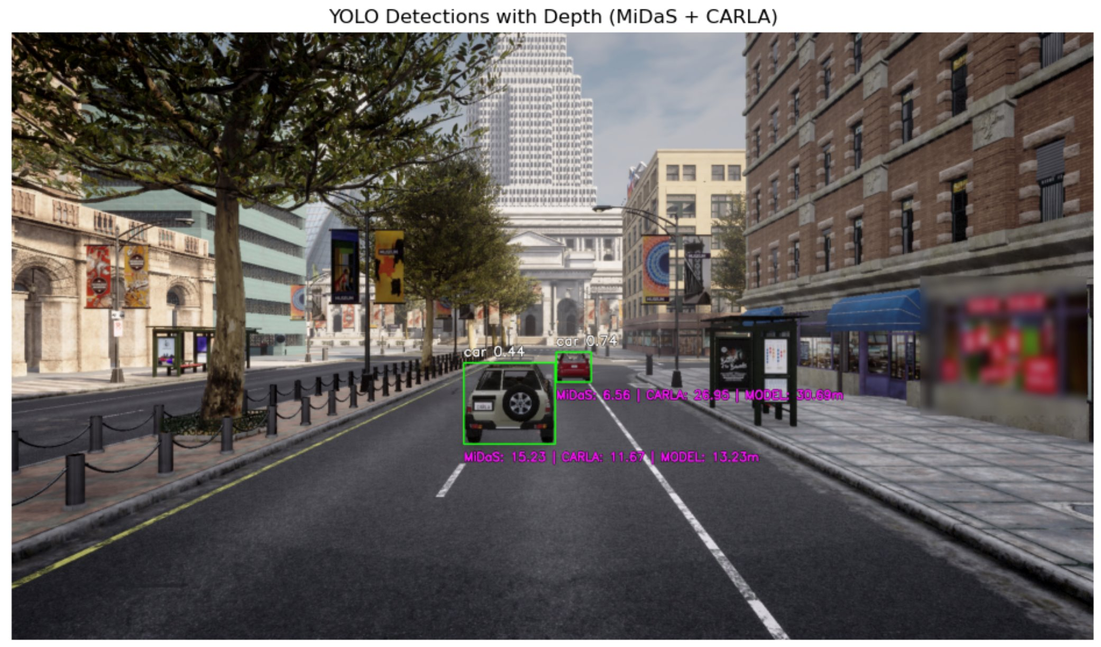

Methodology

Planned Approach Description
This study proposes a modular, vision-based approach for estimating the distance to a lead vehicle using monocular camera input. The planned pipeline integrates object detection, depth estimation, privacy-preserving preprocessing, and structured modeling, trained primarily on simulated data with the intention to generalize real-world scenarios.
Simulated data are collected from the CARLA environment and stored in a GCP cloud-based repository for further use. Preprocessing includes an 80/20 train-test split, resizing, and data augmentation to enhance robustness. A dedicated privacy filtering component is included to remove personally identifiable information (PII) from all input images. Two separate YOLO models are used: one for face detection (Yang et al., 2016) and another for license plate detection (Li et al., 2019). Detected regions are anonymized using Gaussian blur. As part of ongoing development, these detection tasks will be consolidated using a single segmentation-based YOLOv8( Ultralytics, 2023) model to reduce inference latency and improve efficiency.
Object detection is performed using the YOLOv8 architecture, which returns bounding boxes and class labels for relevant objects, including vehicles, pedestrians, and traffic signs. These outputs define the regions of interest for depth estimation.
The pipeline evaluates three monocular depth estimation models: MiDaS, ZoeDepth, and Depth Anything. MiDaS uses a Vision Transformer backbone and multi-dataset training for robust depth prediction (Ranftl et al., 2022). ZoeDepth combines relative and metric depth cues for zero-shot generalization (Bhat et al., 2023). Depth Anything builds on the Segment Anything architecture and is trained on large-scale unlabeled data to improve dense depth estimation in complex scenes (Liu et al., 2024). The depth outputs are converted into metric distances using camera intrinsics and, when applicable, reference-based cues such as lane widths or license plate sizes.
The proposed modeling component leverages a supervised machine learning model, such as XGBoost, to predict vehicle distance from structured input features. These features include object class, bounding box geometry, extracted depth statistics, and known camera parameters. Ground truth distances obtained from CARLA and KITTI are used for supervised training. The model aims to learn reliable mappings between object features and physical distances, enabling generalized inference across new frames.
In addition to the learning-based approach, a one-shot geometric estimation method is under development. This method approximates vehicle distance using the known focal length of the camera and the real-world width or height of a license plate. By applying the pinhole camera model, the method uses the size of the detected license plate in the image frame to estimate distance via the formula:
$$Distance=\frac{f*H}{h}$$
where f is the camera’s focal length, H is the known real-world height of the license plate, and h is the height of the license plate in the image (in pixels). This approach assumes minimal tilt and distortion and is intended to serve as a computationally efficient alternative for use cases where learning-based depth models may be unavailable or fail.

To further enhance distance estimation accuracy, we plan to explore a spatio-temporal approach that incorporates information across consecutive video frames. By leveraging temporal consistency and motion cues, this method may improve stability in predictions and address depth ambiguity in single-frame inference.
To ensure that the model generalizes beyond simulated data, the KITTI benchmark dataset is incorporated for validation. KITTI includes both RGB images and ground truth depth maps, allowing for robust cross-domain comparison.

Figure 2. Architecture Diagram
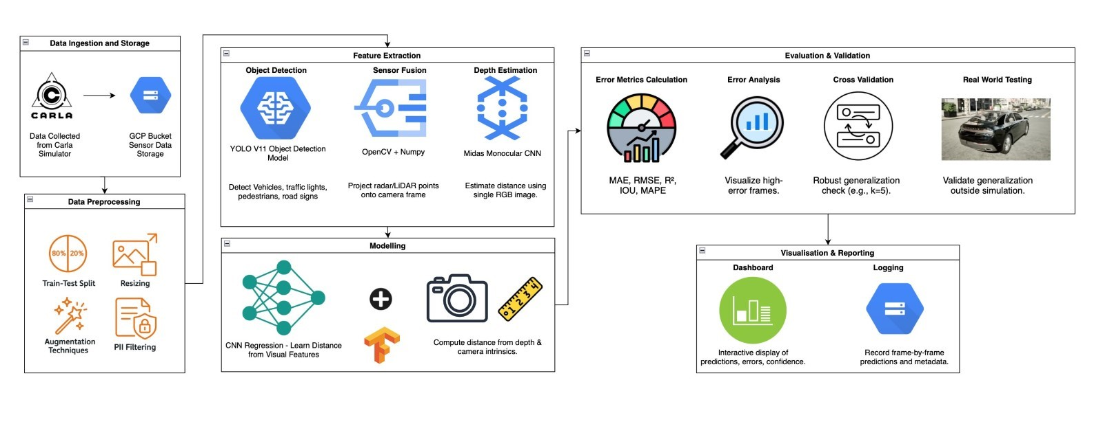
From object detection to depth estimation and hybrid fusion for final prediction.

Methodology for Model Evaluation and Validation
The system will be evaluated using both qualitative and quantitative methods to assess its accuracy, efficiency, and generalizability. Visually, the model’s outputs will consist of annotated video frames in which detected vehicles are enclosed within bounding boxes. Each box will include a numerical distance estimate derived from either monocular depth models or a one-shot geometric approach based on license plate dimensions and camera focal length. These outputs are intended to be interpretable and easily validated by human reviewers. Additionally, all frames will include automated privacy protection through the detection and blurring of faces and license plates, using YOLO-based models and Gaussian masking techniques.
Quantitatively, model performance will be evaluated using established benchmarks. The accuracy of distance estimation will be measured in relation to ground truth values available in CARLA and KITTI datasets. Object detection will be assessed based on its ability to correctly identify and localize vehicles and PII under varying scene conditions. Evaluation will be carried out across training, validation, and testing datasets, with specific attention paid to the model’s robustness when transitioning from simulated to real-world inputs. Evaluation procedures will include comparisons across different configurations—monocular depth models, geometric estimators, and combinations thereof—to determine optimal system settings.

Expected Results
We expect the final system to deliver real-time, high-resolution outputs in which detected vehicles are annotated with overlaid distance estimates. These visualizations should remain stable and interpretable across a range of urban driving scenarios, making them suitable for downstream applications in driver assistance or autonomous control systems. Additionally, the PII filtering component is expected to operate with complete reliability, ensuring that all faces and license plates are consistently blurred prior to storage or downstream processing.
In terms of performance, the system is designed to meet several quantitative benchmarks. These include achieving a root mean square error (RMSE) of ≤ 5% for distance estimation, a mean average precision (mAP) of at least 80% for object detection, and inference times under 60 milliseconds to support real-time responsiveness. The model size is targeted to remain below 50 megabytes to enable deployment on mobile devices. Additionally, the system should maintain performance within a 10% margin under adverse weather conditions and ensure 100% blurring accuracy for privacy-sensitive content. These results will demonstrate the system's accuracy, efficiency, and deployability in both controlled and real-world settings.

Table 1. Key performance metrics
Metric | Target Value | Why It Matters
RMSE | ≤ 5% | High-accuracy distance estimation
Detection mAP | ≥ 80% | Reliable vehicle detection
Inference time | ≤ 60 ms | Real-time decision making
Model size | ≤ 50 MB | Deployability on mobile
Weather Robustness | ≤ 10% drop | Real-world usability
Privacy Compliance | 100% blurring | Legal & ethical

References
Bhat, A., Hu, Y., Schwing, A. G., & Kitani, K. M. (2023). ZoeDepth: Zero-shot transfer by combining relative and metric depth. arXiv preprint arXiv:2302.12288. https://arxiv.org/abs/2302.12288
Bochkovskiy, A., Wang, C. Y., & Liao, H. Y. M. (2020). YOLOv4: Optimal speed and accuracy of object detection. arXiv preprint arXiv:2004.10934. https://arxiv.org/abs/2004.10934
Fabbri, M., Lanzi, A., Calderara, S., Palazzi, A., Alletto, S., & Cucchiara, R. (2018). Incremental-free online learning of pedestrian detection. Computer Vision and Image Understanding, 173, 9–21. https://doi.org/10.1016/j.cviu.2018.02.001
García, F., Jiménez, F., Armingol, J. M., & Naranjo, J. E. (2017). Autonomous vehicle control systems for safe crossings in non-signalized intersections. Sensors, 17(2), 282. https://doi.org/10.3390/s17020282
Geiger, A., Lenz, P., & Urtasun, R. (2012). Are we ready for autonomous driving? The KITTI vision benchmark suite. In 2012 IEEE Conference on Computer Vision and Pattern Recognition (pp. 3354–3361). https://doi.org/10.1109/CVPR.2012.6248074
Liu, Z., Yu, T., Zheng, S., Lin, Y., & Dai, Q. (2024). Depth Anything: Unleashing the power of large-scale unlabeled data. arXiv preprint arXiv:2401.10462. https://arxiv.org/abs/2401.10462
Mohiyuddin, A. M., Dhanalakshmi, R., & Saravanan, R. (2022). YOLO based object detection and classification for smart retail applications. Materials Today: Proceedings, 56, 472–478. https://doi.org/10.1016/j.matpr.2021.09.094
Ranftl, R., Lasinger, K., Hafner, D., Schindler, K., & Pock, T. (2022). Towards robust monocular depth estimation: Mixing datasets for zero-shot cross-dataset transfer. IEEE Transactions on Pattern Analysis and Machine Intelligence, 44(3), 1623–1637. https://doi.org/10.1109/TPAMI.2020.3019967
Redmon, J., & Farhadi, A. (2018). YOLOv3: An incremental improvement. arXiv preprint arXiv:1804.02767. https://arxiv.org/abs/1804.02767

